Chapter 17, Problem 65.

Given that

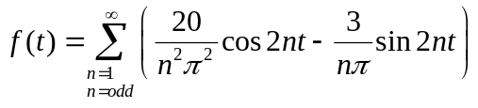

plot the first five terms of the amplitude and phase spectra for the function.

